September 7 | From 4 to 8 PM | Fairview Grange #1351  6270 Tuscarawas Road  Industry, PA 15052
What to Recycle? – Bring to the Grange 4-8 PM only
- Computers, Monitors & Peripherals (all types)
- Laptops, Tablets
- Televisions (all types & sizes)
- Printers, Copiers, Fax, & Scanners
- Radio & Telephone Equipment
- Gaming Consoles & Systems
  - No Loose Batteries or Smoke Detectors
  - No Personal Hygiene or Medical Equipment
  - No Paper, Loose Software, or VCR Tapes

Sponsored by:
Fairview Grange,
Ohioville Borough &

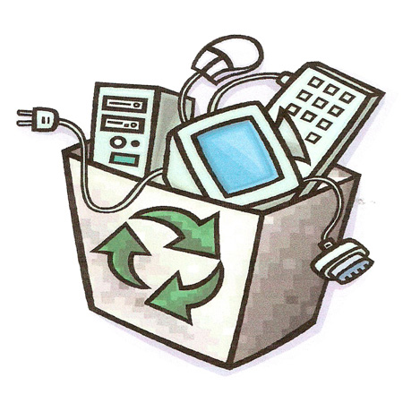
Ohioville
Electronics Recyling Drive

